

PHASE II- THIRD YEAR
STUDENT NAME : ……………………………………………………………………….

STUDENT I.D: ……………………………………………………………………….
OFFICIAL EMAIL: ………………………………………………………………………

Benha University Faculty of Medicine
Integrated program 2023-2024
1
Why portfolio?
In the current health care environment, it is not sufficient to say you are up to date, It is essential to provide evidence . This portfolio is intended for keeping and recording all educational activities assigned to the student during the semester. The student's work is evaluated and approved by the faculty member or module coordinator who assigned the student to this work . The student keeps his/her portfolio throughout the semester and delivers it to the coordinator at the end of the semester. Student’s reflection
on the learning process is essential for improvement of educational process

Integrated program Team

Contents
- Basic information
- Module committee.
- Schedule
- Assessment Methods
- Interactive sessions
- Modules

- Summary of teaching activities.
- Practical / clinical skills
- Interactive sessions
- Skill Lab schedule
- Quizzes & assessments
- Assignments
- Professionalism
- Student’s reflection

Basic information of modules

1st Module
Title | Community Medicine and public health
Code | COM321
Coordinator | Dr./ Hala Abed
Department (s)offering the module | Community, Environmental and Occupational medicine & Internal medicine
Department responsible for the module | Community, Environmental and Occupational medicine
Academic year | 3rd year
Semester | 6th semester
Credit hours | 6 credit hours
Allocated marks | 150 marks
Module duration | 6 weeks
2nd Module
Title | Forensic Medicine & Clinical Toxicology
Code | FOCT322
Coordinator | Dr. Marwa Morad
Department (s)offering the module | Forensic Medicine & Clinical Toxicology
Department responsible for  the module | Forensic Medicine & Clinical Toxicology
Academic year | 3rd year
Semester | 6th semester
Credit hours | 4 credit hours
Allocated marks | 100 marks
Module duration | 4 weeks
3rd Module
Title | Evidence base medicine & research methods
Code | EBMR 323
Coordinator | Prof. Magdy Abd Elmougood
Department (s)offering the module | Hepatology
Department responsible for  the module | Hepatology
Academic year | 3rd year

Semester | 6th semester
Credit hours | 2 credit hours
Allocated marks | 50 marks
Module duration | 2 weeks
4th Module
Title | Ophthalmology
Code | OPTH 324
Coordinator | Dr. Ibrahim Abd Elkhalek
Department (s)offering the module | Ophthalmology
Department responsible for the module | Ophthalmology
Academic year | 3rd year
Semester | 6th semester
Credit hours | 6 credit hours
Allocated marks | 150 marks
Module duration | 6 weeks
  - Modules Committee
    - General Supervisor of modules: Assistant Prof. Eman Mohammed Araby
    - Semester Coordinator: Dr. Marwa Mourad
    - Module Coordinators :
    - Assistant Prof. Hala Ali Abed
    - Dr. Marwa Mourad
    - Prof. Magdey Abdel Mougood
    - Dr. Ibrahim Abdelkhalk
3.Schedule

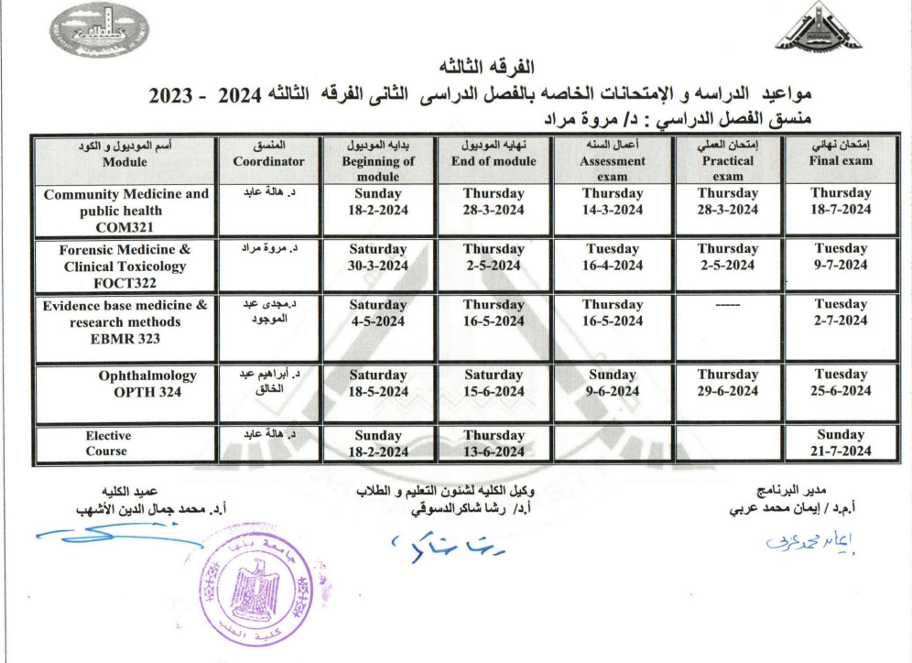

4. Assessment
- Formative
- Summative

In this Course your performance will be assessed according to the following
summative exam:
o Continuous Assessment | 30%
o Practical | 30 %
o Final Exam | 40 %
o Total 100 %

  - Interactive sessions
Engaging students into the educational process using different educational strategies like Case based learning (CBL)- Tutorial , Self- directed learning (DSL)
. Student will share through
Φ Topic Presentations
Φ Topic summarization
Φ Preparing and presenting multimedia presentations.
Φ Creating infographics, web pages, groups and blog posts, and collecting photos relevant to the lecture.
Φ Collective or Individual projects,
Φ Group or Individual Presentations
Φ Research

1st Module

Code | CHs | Contents
COM321 | 6 | Lectures | Practical | Students class activities
 |  |  |  | Tutorial | CBL | DSL | Field visits
COM321 | 6 | 41 | 42 | 20 | 4 | 4 | 8
يتم التدريس بالمدرج الأرضي من 8 ص – 12 ظ
No. | Lecture Title | Staff member | Date
 | L (1)  Introduction, Health and disease& orientation session | ا.د. ايمان عربي | Monday  19/2/2024
 | L (2)  General epidemiology 1 | ا.د. ايمان عربي | Monday  19/2/2024
 | L (3)  General epidemiology 2 | د.ايمان شبل | Tuesday  20/2/2024
 | L (4)  General epidemiology 3 | د.ايمان شبل | Tuesday  20/2/2024
 | L (5)  Prevention and control 1 | ا.د. ايمان عربي | Wednesday  21/2/2024
 | L (6)  Prevention and control 2 | د.مي المهدي | Wednesday  21/2/2024
 | L (7)  pertussis | د.مي المهدي | Saturday  24/2/2024
 | L (8)  Meningitis | ا.د. شيرين عبد الوهاب | Saturday  24/2/2024
 | L (9)  Measles, Rubella | ا.د. شيرين عبد الوهاب | Sunday25/2/2024
 | L (10) streptococci and Prevention of rheumatic fever | ا.د. شيرين عبد الوهاب | Sunday 25/2/2024
 | L (11)  TB | د.مي المهدي | Monday26/2/2024
 | L (12)  TB | د.مي مجدي | Monday 26/2/2024
 | L(13)  Influenza | د.عبير السيد | Tuesday  27/2/2024
 | L (14)  Poliomyelitis | د.عبير السيد | Tuesday  27/2/2024
 | L (15)  Typhoid infection | أ.د. دعاء ابراهيم | Wednesday  28/2/2024
 | L (16)  Brucellosis | د.مي المهدي | Wednesday  28/2/2024
 | L (17)  Viral hepatitis | د.ايمان شبل | Saturday  2/3/2024
 | L (18)  Viral hepatitis | د.ايمان شبل | Saturday  2/3/2024
 | L (19)  Tetanus | ا.د. هالة عابد | Sunday  3/3/2024
 | L (20)  Leprosy | ا.د. هالة عابد | Sunday  3/3/2024
 | L (21)  Rabies | د.مي مجدي | Monday  4/3/2024
 | L (22)  Yellow fever | ا.د. هالة عابد | Monday  4/3/2024
 | L (23)  Malaria | د.عبير السيد | Tuesday  12/3/2024
 | L (24)  STDs | د.عبير السيد | Tuesday  12/3/2024
 | L(25)Anti schistosomiasis campaign | د بسمة هاني | Saturday  16/3/2024
 | L(26) IHD | د بسمة هاني | Saturday  16/3/2024
 | L (27)  Cancer | أ.د. دعاء ابراهيم | Sunday  17/3/2024
 | L(28) Vaccine preventable cancer | أ.د. دعاء ابراهيم | Sunday  17/3/2024
 | L(29) PHC | د. نشوى نبيل | Monday  18/3/2024
 | L (30)  School health | د. نشوى نبيل | Monday  18/3/2024
 | L (31)  Maternal health | د. مي مجدي | Tuesday  19/3/2024
 | L (32)  Maternal health | د. شيماء جمال | Tuesday  19/3/2024
 | L (33)  Child health | د. بسمة هاني | Wednesday  20/3/2024
 | L (33)  Child health | د. بسمة هاني | Wednesday  20/3/2024
 | L (35)  Geriatric health | د. شيماء جمال | Saturday  23/3/2024
 | L (36)  Rural health | د. شيماء جمال | Saturday  23/3/2024
 | L (37)  Occupational health | د. نشوى نبيل | Sunday  24/3/2024
 | L (38)  Adolescent health | د. مي مجدي | Sunday  24/3/2024
 | L (39)  Food sanitation | د. شيماء جمال | Monday  25/3/2024
 | L (40)  Air pollution | د. شيماء جمال | Monday  25/3/2024
 | L (41)  Heat | د. نشوى نبيل | Tuesday  26/3/2024

Site: Halls of community department & Forensic & Toxicology department

No | Department | Practical Title | Signature of demonstrator | Date
 |  | P1: Vaccination 1
 |  | P2: Vaccination 2
 |  | P3: Vaccination 3
 |  | P4: Vaccination 4
 |  | P5: Infection control-1
 |  | P6: Infection control-2
 |  | P7: DM
 |  | P8: Investigation of outbreak
 |  | P9: Epidemic curve
 |  | P10: Noise 1
 |  | P11: Noise 2
 |  | P12: Growth monitoring 1
 |  | P13: Growth monitoring 2
P13:
Water Purification steps
P14:
Case study: (occupational case)
P15:
Health hazards of radiation
 |  | P16: Demography (estimation)
 |  | P17: Hazards of handling blood
 |  | P18: Hazards of handling blood
 |  | P19: Vibration
 |  | P20: Ergonomics 1
 |  | P21: ` Ergonomics 2

INTERACTIVE LEARNING (CLASSROOM ACTIVITIES)

Site: at the academic department ( Public health – Forensic &Toxicology- Ophthalmology)
Attach to your portfolio all activities that you shared in / materials shared by the departments and the students’ groups

Activity | Title | Signature of  Tutor | Date

Quizzes & assessments
Either online quizzes or in the class room

Type | Date | Grade | Signature
Formative
Mid assessment | 14-3-2024
Practical exam | 28-3-2024

Assignments
Attach to your portfolio all assignments that you will have during the module

Assignments | Department | Date | Aim | Signature

Professionalism
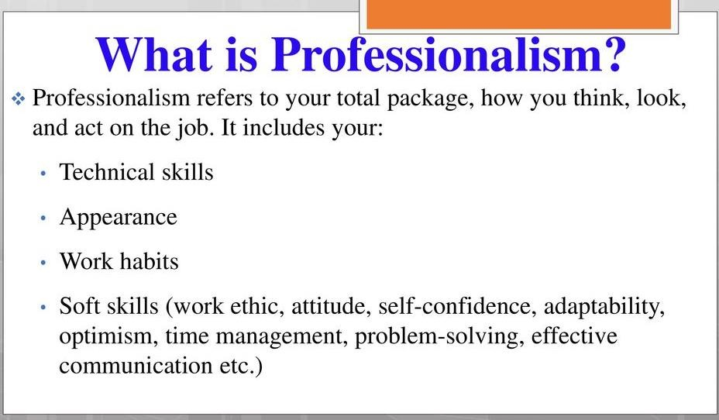

Items covered | Allocated Mark | Student score
Attends the whole session | 1 marks
Share in student activity | 6 marks
Behaves honestly and in a professional manner | 0.5 mark
Takes on appropriate share of team work | 0.5 mark
Fulfills obligations undertaken | 0.5 mark
Uses appropriate language in discussion with Professors and colleagues | 0.5 mark
Total score | 9 marks
Student’s Reflection
Please reflect on your learning experience during the module.

Strengths | Weakness

2nd Module
Forensic Medicine & Clinical Toxicology

Code | CHs | Contents
FOCT322 | 4 | Lectures | Practical | Students class activities
 |  |  |  | Tutorial | CBL | DSL
FOCT322 | 4 | 24
يتم التدريس بالمدرج الأرضي من 8 ص – 12 ظ
No. | Lecture Title | Staff member | Date
PRACTICAL TRAINING
Site: Halls of community department & Forensic & Toxicology department

No | Department | Practical Title | Signature of demonstrator | Date

INTERACTIVE LEARNING (CLASSROOM ACTIVITIES)
Site: at the academic department (Public health – Forensic &Toxicology)
Attach to your portfolio all activities that you shared in / materials shared by the departments and the students’ groups

Title | Signature of  Tutor | Date

STUDENT’S ACTIVITY Skill lab

Skill | Date | Signature

Quizzes & assessments
Either online quizzes or in the class room

Type | Date | Grade | Signature
Formative
Mid assessment | 16-4-2024
Practical exam | 2-5-2024

Assignments
Attach to your portfolio all assignments that you will have during the module

Assignments | Department | Date | Aim | Signature

Professionalism

Items covered | Allocated Mark | Student score
Attends the whole session | 2 marks
Share in student activities | 2 marks
Behaves honestly and in a professional manner | .5 mark
Takes on appropriate share of team work | .5 mark
Fulfills obligations undertaken | .5 mark
Uses appropriate language in discussion with Professors and colleagues | .5 mark
Total score | 6 marks
Student’s Reflection

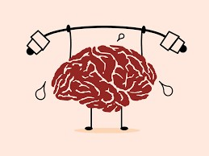


Please reflect on your learning experience during the module
Strengths | Weakness

3rd Module
Evidence base medicine & research methods
Code | CHs | Contents
EBMR 323 | 2 | Lectures | Practical | Students class activities
 |  |  |  | Tutorial | CBL | DSL
EBMR 323 | 2 | 12
يتم التدريس بالمدرج الأرضي من 8 ص – 12 ظ

No. | Lecture Title | Staff member | Date

PRACTICAL TRAINING
Site: the department practical room
No | Department | Practical Title | Signature of demonstrator | Date
INTERACTIVE LEARNING (CLASSROOM ACTIVITIES)
Site: at the academic department (Public health- Forensic & Toxicology- Ophthalmology)
Attach to your portfolio all activities that you shared in / materials shared by the departments and the students’ groups

Activity | Title | Signature of  Tutor | Date

Quizzes & assessments
Either online quizzes or in the class room

Type | Date | Grade | Signature
Formative
Mid assessment | 16-5-2024

Assignments
Attach to your portfolio all assignments that you will have during the module

Assignments | Department | Date | Aim | Signature

Professionalism

Items covered | Allocated Mark | Student score
Attends the whole session | 1mark
Share in student activities | 1 mark
Behaves honestly and in a professional manner | 0.25 mark
Takes on appropriate share of team work | 0.25 mark
Fulfills obligations undertaken | 0.25 mark
Uses appropriate language in discussion with Professors and colleagues | 0.25 mark
Total score | 3 marks

Student’s Reflection
Please reflect on your learning experience during the module.

Strengths | Weakness

4th Module
Ophthalmology
Code | CHs | Contents
OPTH 324 | 6 | Lectures | Practical | Students class activities
 |  |  |  | Tutorial | CBL | DSL
OPTH 324 | 6 | 36
يتم التدريس بالمدرج الأرضي من 8 ص – 12 ظ
No. | Lecture Title | Staff member | Date
PRACTICAL TRAINING
Site: Halls of community department - Forensic & Toxicology department – Ophthalmology department
No | Department | Practical Title | Signature of demonstrator | Date

INTERACTIVE LEARNING (CLASSROOM ACTIVITIES)
Site: at the academic department (Public health- Forensic & Toxicology- Ophthalmology- Ophthalmology department)
Attach to your portfolio all activities that you shared in / materials shared by the departments and the students’ groups
Activity | Title | Signature of  Tutor | Date

STUDENT’S ACTIVITY (Skill lab)

Skill | Date | Signature

Quizzes & assessments
Either online quizzes or in the class room

Type | Date | Grade | Signature
Formative
Mid assessment | 9-6-2024
Practical exam | 29-6-2024

Assignments
Attach to your portfolio all assignments that you will have during the module

Assignments | Department | Date | Aim | Signature

Professionalism
Items covered | Allocated Mark | Student score
Attends the whole session | 1 marks
Share in student activities | 6 marks
Behaves honestly and in a professional manner | 0.5 mark
Takes on appropriate share of team work | 0.5 mark
Fulfills obligations undertaken | 0.5 mark
Uses appropriate language in discussion with Professors and colleagues | 0.5 mark
Total score | 9 marks

Student’s Reflection
Please reflect on your learning experience during the module.

Strengths | Weakness

Appendix A
Fundamental physical examination skills

 | Skill | Required
1. | Measuring body temperature
2. | Measuring pulse rate, respiratory rate and blood pressure
3. | Anthropometric Measurements and assessment of  nutritional status | √
4. | Chest examination
5. | Heart examination
6. | Abdominal examination
7. | Locomotor system examination
8. | Nervous system examination
9. | Examination of the jugular veins
10. | Ear examination
11. | Throat examination
12. | External Eye and fundus examination | √
13. | Breast examination
14. | Examination of the thyroid
15. | Lymph nodes examination
16. | PV examination
17. | Assessment of uterine fundus level in pregnancy
18. | PR examination
19. | Examining lumps

Appendix B
Basic diagnostic and intervention procedures
 | Skill | Required
1. | Performing venipuncture and collecting blood samples.
2. | Inserting a cannula into peripheral veins
3. | Establishing peripheral intravenous access and setting up  an infusion; use of infusion devices
4. | Giving intramuscular, subcutaneous, intradermal and  intravenous injections
5. | Suturing of superficial wounds
6. | Performing cardiopulmonary resuscitation and basic life-  support
7. | Performing and interpreting basic bedside laboratory tests
8. | Performing and interpreting ECG
9. | Managing an electrocardiograph (ECG) monitor
10. | Taking swabs for different diagnostic purposes
11. | Using a nebulizer for administration of inhalation therapy
12. | Performing male and female bladder catheterization
13. | Administering basic oxygen therapy
14. | Wound care and basic wound dressing
15. | Managing Blood transfusion
16. | Inserting a nasogastric tube
17. | Administering local anesthetics
18. | Performing the procedure of normal labor

Appendix C Practical skills
 | Skill | Required
1. | Dissecting the different parts and organs of the human  body
2. | Performing Biochemical and microscopic urine and stool  analysis
3. | Performing basic biochemical blood tests
4. | Preparing urine and stool specimen for microscopic  examination
5. | Identification of parasites and parasitic ova under the  microscope
6. | Identification of different normal tissue sections under the  microscope
7. | Identification of different pathological alterations in tissue  sections under the microscope
8. | Identification of gross pathological alterations in different  body organ specimens
9. | Determining blood group and performing cross matching  and computability tests
10. | Preparing and examining blood films and assessing  hemoglobin value in a blood sample
11. | Obtaining and handling a blood sample for culture
12. | Performing and interpreting basic respiratory function  tests.
13. | Identifying different bacteria and fungi under the  microscope
14. | Differentiating different bacterial growth in culture


للطالب دور أساسي في عملية الإرشاد الأكاديمي لما له من أثر إيجابي على تقدمه في العملية التعليمية وأيضا على الناحية النفسية لذا يجب على الطالب الإستعداد والحرص الدائم على تفعيل هذه المقابلات ويجب على الطالب حضور جلسة واحدة على الأقل خلال مدة الموديول ومتابعة حالته الدراسية مع مرشده

توقيع المرشد | نتائج الجلسة | ملخص جلسة الإرشاد | مسلسل

………………………………………………………………………………………………………………………………………

………………………………………………………………………………………………………………………………………

………………………………………………………………………………………………………………………………………

………………………………………………………………………………………………………………………………………

………………………………………………………………………………………………………………………………………

………………………………………………………………………………………………………………………………………

………………………………………………………………………………………………………………………………………

………………………………………………………………………………………………………………………………………

………………………………………………………………………………………………………………………………………

………………………………………………………………………………………………………………………………………

………………………………………………………………………………………………………………………………………

………………………………………………………………………………………………………………………………………

………………………………………………………………………………………………………………………………………

………………………………………………………………………………………………………………………………………

………………………………………………………………………………………………………………………………………

………………………………………………………………………………………………………………………………………

………………………………………………………………………………………………………………………………………

………………………………………………………………………………………………………………………………………

